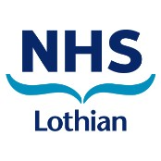
Molecular Pathology Request Form
Molecular Pathology, Department of Laboratory Medicine,
Royal Infirmary of Edinburgh, 51 Little France Crescent, Edinburgh, EH16 4SA
Tel. 0131 2427141 molecular.pathology@nhslothian.scot.nhs.uk www.edinburghlabmed.co.uk

REQUESTOR DETAILS:
Sending Department:
Requesting Clinician:
Report to be issued to (clinician/email address/location):
Contact Telephone: |  | Email:

PATIENT DETAILS:
Surname: |  |  | Forename:
CHI (or Date of Birth): |  |  |  | Sex: |  | M F
Address (if known):
Specimen type | Extracted DNA | Concentration
Specimen Ref. No.: |  | Diagnosis:
Sample collection date: |  | Priority: |  |  | Normal Urgent

TEST REQUESTED:
AML IDH1

Please send extracted DNA (minimum of 10ng) for testing.

*Please ensure contacts details of requesting clinician are included to enable results to be emailed directly *

